# Chrome_TC_01:Purchase_Invoice_Creation

### Orient LED Login Page.

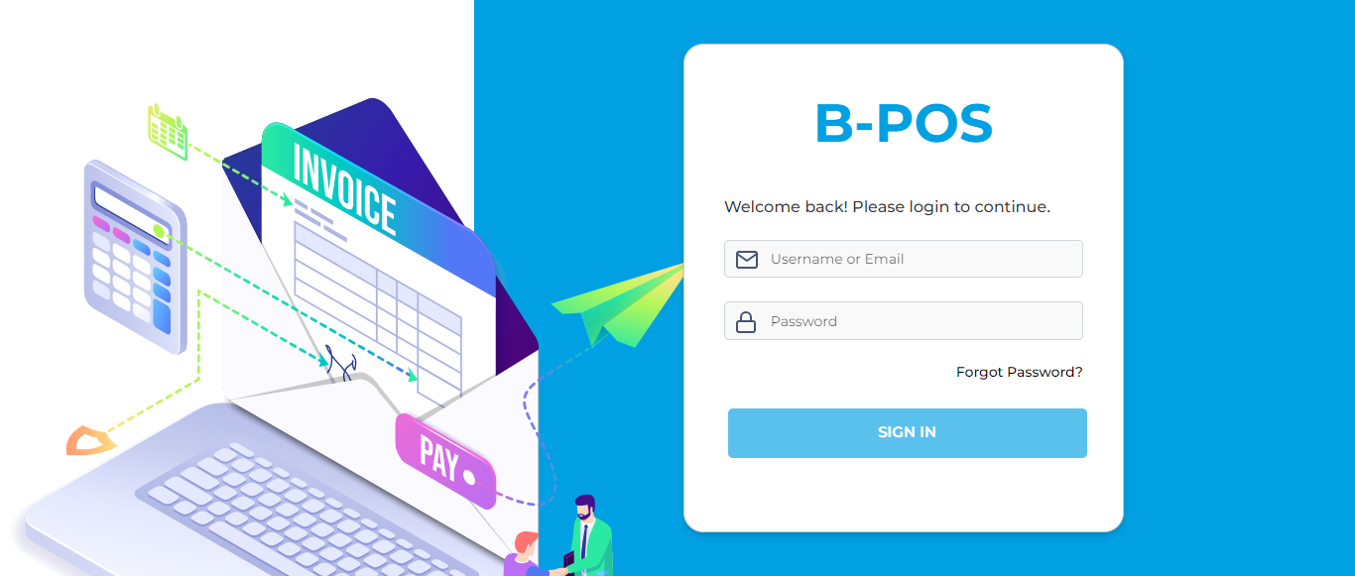

### The Home page with lot of navigation options to navigate different modules and serving as the entry point to the website.

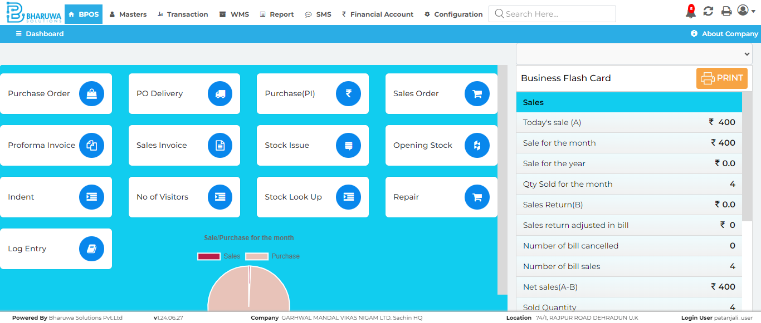

### Transaction module with lot of sub-modules to perform vairous transactinos for user.

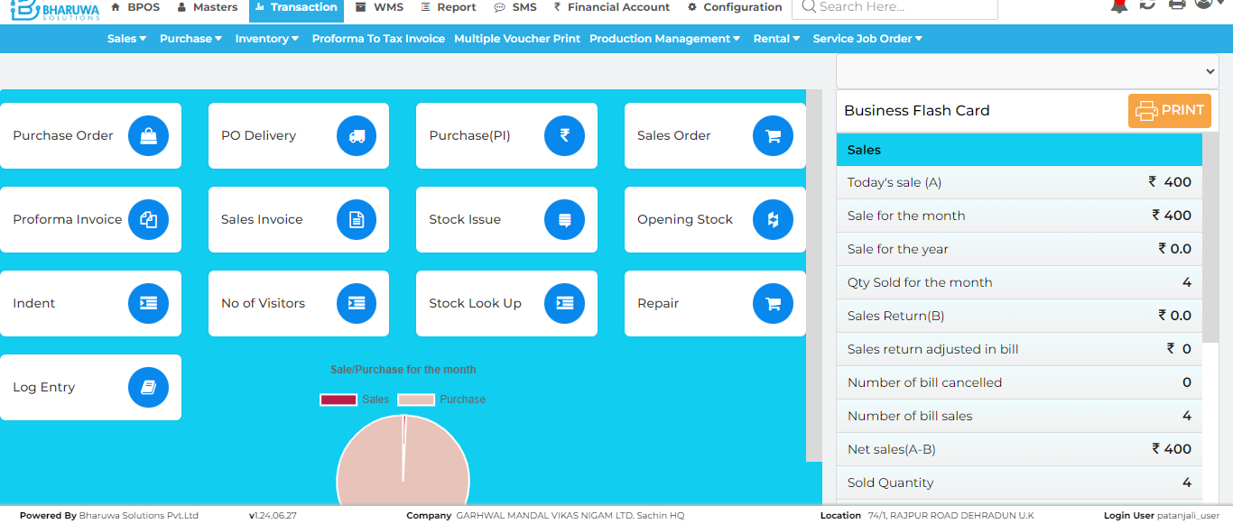

### Purchase Invoice screen where user can purchase stock for selected items.

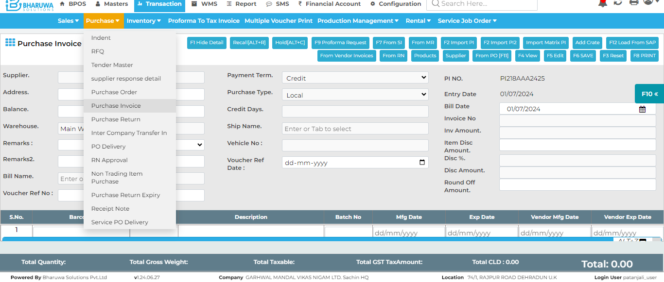

### Purchase invoice created Successfully to add stock for selected items for preferred customer.

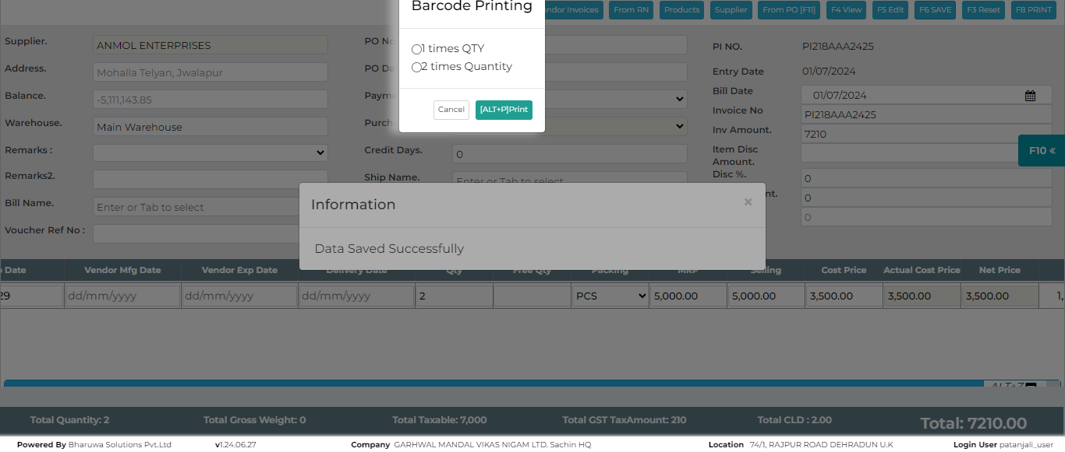

#### TC_01 - TEST PASSED